This document is merely to point out the differences in confessional count numbers between my findings and the official numbers posted on Survivor Sucks. The guidelines I use can be found [here](https://docs.google.com/document/d/18ofsPiVWxSejzSjEGlU8KEx4Og2ddEJScCV23RsCPIA/edit?usp=sharing).

**Survivor Sucks Season 03 Counts** ([link](https://goo.gl/photos/ob2gftpkWr75hzv18))

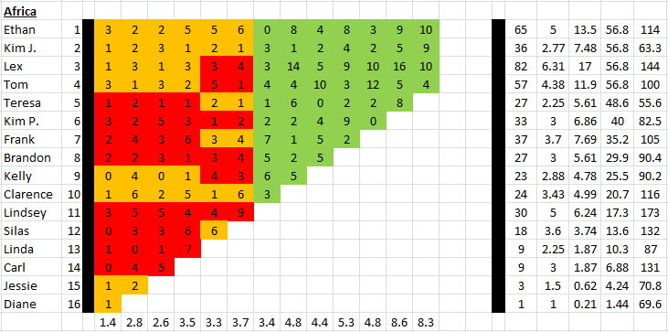

**My Season 03 Counts** (link)

**Differences**

[Episode 01](https://docs.google.com/document/d/1bxe761X3TbZVD7-T0nS4jG_Newg4KdV_Vy01kOrvaFE/edit?usp=sharing)

* **Ethan 4 (+1)** I got a total of 4 confessionals for Ethan instead of the established 3. No significant gaps.
* **Frank 3 (+1)** Confessional #5 has an 11s gap.

Episode 0

**No Change**

* Episode

|  |  |  |
| --- | --- | --- |
| **Castaway** | **Count** | **Change** |
|  |  |  |
| **Total** |  |  |

**Revised Sucks Counts** (link)